# First Report :

Navigation : Go to Navigator( ) 🡪 Tools 🡪 Reports and Analytics 🡪 Browse Catalog.

Catalog mainly consists of 3 items,

1. My Folder : Specific to a user.

2. Shared Folders : Common for the all the users of the cloud instance.

3. Tasks :

Offerings :

1. Financial.

2.Order Management.

3. Procurement... etc.

**Every BI report consists of 2 parts:**

1. **Data Model** 🡪 It consists of Data source.
2. **Layout** 🡪 It can be created by manually or by using a wizard.
3. **Data Model** :
   1. After Navigating to Browse Catalog, click on new and under Published Reporting, click Data Model.
   2. It consists of 6 properties.
      1. Data Set 🡪 Used to retrieve the data from various data sources (like SQK, Excel, Web service, CSV, etc.).
      2. Event Trigger 🡪
      3. Flex Fields 🡪
      4. List of Values 🡪
      5. Parameters 🡪
      6. Bursting 🡪
   3. We need to create a dataset using one of the data sources(mostly SQL)
      1. Give the name of the Data Model, source and the type (either Standard SQL or Procedure call or Non-Standard SQL).
      2. After that we need to view the data and save it sample data to generate a xml required to generate a report for that data model.
4. **Report Layout** :
   1. Once we save the Data Model, we can create a report for that by clicking on create report button.
   2. We can create a layout either using a wizard or manually.
   3. Once we create the report, we can run it 2 ways
      1. We can run it from catalog.(usually developers do this)
      2. We can run from fusion application by creating an ESS job (Functional people do this).

# Value Sets: Not yet complete

They are the list of values we give to a Flex Fields.

There are typically 5 value types of Value-sets.

1. **Format Only**: It consists of any restrictions to the value set.

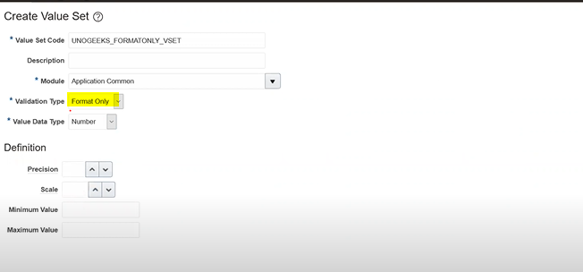

1. **Independent**: To get some LOV’s for a field, as the name suggest it is independent of any.

* You can also manage values there, after saving it will be enabled.

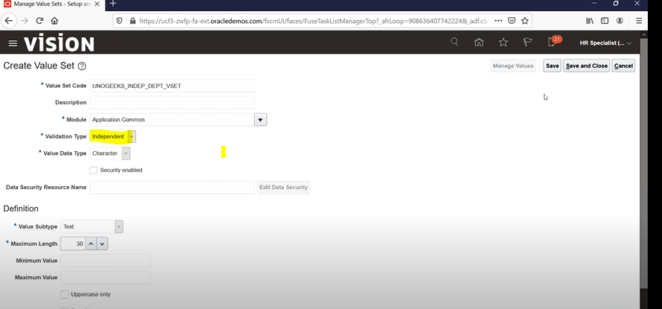

1. **Dependent Value Set**: As the name suggest it depends on an Independent value set. Creation is same as independent value set but you must select an independent value set at the time of creation.

* In manage value page you need to select the independent value set’s value.

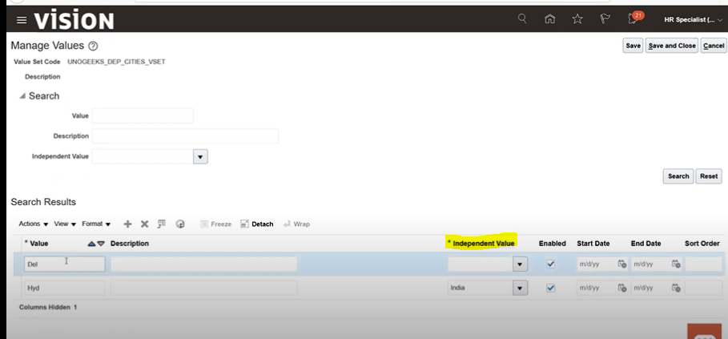

1. **Subset**: In this you can’t add any new value, you can just select a group of values(ideally they should form a cluster) from an independent value set on which the subset depends on.

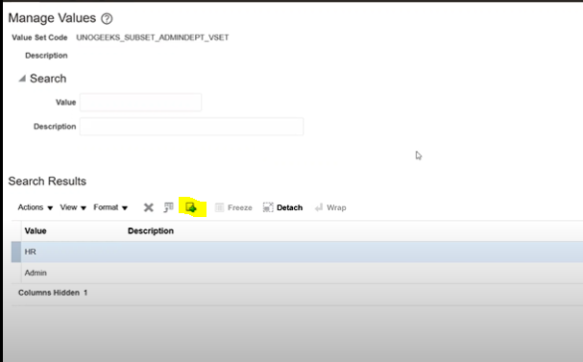

1. **Table**: Here the data is directly fetched from the table.

* The benefit of using Id Column Name is whatever the value you selected for the field at the backend it stores the id value only.

Doubt: What if the 2 or more values of the flex field value has same id value?

